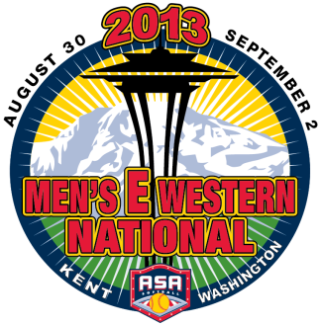

2013 Men’s E Western National Championship

Team Name | City/State
ASA Association | Region#
Coach's Name | Cell number
Address | Home number
City, State, Zip | Office number
E-mail | Best phone during tourney
Back-up contact | Cell number/E-mail

Dates | August 30 (after 6 pm)-Sept. 2 (only if rain)
GAMES WILL BE PLAYED SEPT 2 ONLY IF RAIN DELAYS THE TOURNAMENT
Location | Main complex, Russell Road Complex, Kent, WA
Entry Fee | $400 – Check made out to TEAM SEATTLE NATIONAL EVENTS
 | Due no later than Monday August 26th
Mail to | SCOTT BUSER- TOURNAMENT DIRECTOR
 | 6505 Alfaretta St. SW, Lakewood, WA 98499
 | 253-640-6497 | teamspeed12@comcast.net FAX: 253-472-9500
WEBSITE: |  |  | WWW.TEAMSEATTLEEVENTS.COM

