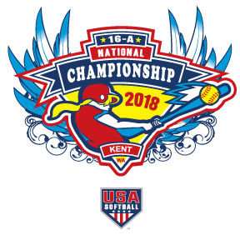
2018 USA SOFTBALL GIRLS’ 16A NATIONAL CHAMPIONSHIP

TOURNAMENT PROGRAMS PRE-ORDER FORM
(please submit all team orders together)

THE TOURNAMENT PROGRAM WILL BE PRINTED IN FULL COLOR

TEAM NAME ____________________________
MANAGER’S NAME _______________________
PHONE ______________________

ORDER MUST BE RECEIVED BY WEDNESDAY JULY 11
# OF PROGRAMS @ $5.00 EACH ________
TOTAL ENCLOSED $ ______________
PLEASE MAIL CHECKS MADE OUT TO “TEAM SEATTLE NATIONAL EVENTS” TO JIM DONNER
PROGRAMS WILL BE AVAILABLE AT TEAM-CHECK IN.

PROGRAMS AT THE GATE WILL BE $8.00.

